Student Name:- Prameet Upadhyay
Student Roll No.:- 1905692
Algorithm Lab. Class Assignment-4
CSE Group 1
Date: - 30th July 2021
- Write a C program for bubble sort to
- Compare the time complexity with the given data set given below and calculate the time complexity based on the CPU clock.
- Plot a graph showing the comparison (n, the input data Vs. CPU times)
Sl No. | Value of n | Bobble Sort (Time Complexity)
Sl No. | Value of n | Best case | Average case | Worst case
1 | 5000 | 0.000000 | 0.081000 | 0.071000
2 | 10000 | 0.000000 | 0.330000 | 0.359000
3 | 15000 | 0.000000 | 0.807000 | 0.793000
4 | 20000 | 0.001000 | 1.346000 | 1.616000
5 | 25000 | 0.000000 | 1.952000 | 2.348000
6 | 30000 | 0.001000 | 2.778000 | 3.601000
7 | 35000 | 0.000000 | 4.184000 | 4.841000
8 | 40000 | 0.000000 | 5.691000 | 6.707000
9 | 45000 | 0.000000 | 6.954000 | 8.340000
10 | 50000 | 0.000000 | 8.543000 | 10.418000

Program
#include<stdio.h>
#include<stdlib.h>
#include<time.h>

void swap(int *xp, int *yp)
{
int temp = *xp;
*xp = *yp;
*yp = temp;
}
void Bubble_sort(int A[],int n){
for(int i=0;i<n-1;i++){
for(int j=0;j<n-i-1;j++){
if(A[j] > A[j+1])
swap(&A[j],&A[j+1]);
}
}
}
int main()
{
int n;
time_t strt,end;
double t;
scanf("%d",&n);
int k = n;
int best[n],avg[n],worst[n];
for(int i=0;i<n;i++){
best[i] = i+1;
avg[i] = rand()%1000;
worst[i] = k;
k--;
}
strt = clock();
Bubble_sort(best,n);
end = clock();
t = end - strt;
printf("Time Complexity for best case : %f\n",(t/CLOCKS_PER_SEC));

strt = clock();
Bubble_sort(avg,n);
end = clock();
t = end - strt;
printf("Time Complexity for avg case: %f\n",(t/CLOCKS_PER_SEC));

strt = clock();
Bubble_sort(worst,n);
end = clock();
t = end - strt;
printf("Time Complexity for worst case : %f\n",(t/CLOCKS_PER_SEC));

for(int i=0;i<n;i++){
printf("%d ",avg[i]);
}
return 0;
}

Output
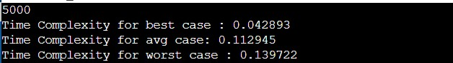

Graph
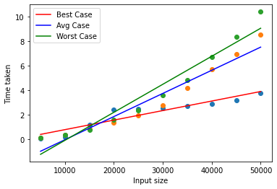

- Write a C program for selection sort to
- Compare the time complexity with the given data set given below and calculate the time complexity based on the CPU clock.
- Plot a graph showing the comparison (n, the input data Vs. CPU times)

Sl No. | Value of n | Selection Sort (Time Complexity)
Sl No. | Value of n | Best case | Average case | Worst case
1 | 5000 | 0.039000 | 0.037000 | 0.035700
2 | 10000 | 0.146000 | 0.1468000 | 0.149000
3 | 15000 | 0.313000 | 0.347000 | 0.330000
4 | 20000 | 0.552000 | 0.501000 | 0.537000
5 | 25000 | 0.922000 | 0.919000 | 0.836000
6 | 30000 | 1.186000 | 1.157000 | 1.248000
7 | 35000 | 1.706000 | 1.559000 | 1.581000
8 | 40000 | 2.269000 | 1.991000 | 2.259000
9 | 45000 | 2.605000 | 2.671000 | 2.654000
10 | 50000 | 3.411000 | 3.240000 | 3.788000

Program
#include <stdio.h>
#include <stdlib.h>
#include<time.h>

void swap(int *x, int *y)
{
int temp = *x;
*x = *y;
*y = temp;
}

void selectionSort(int A[], int n)
{
int i, j, k;
for (i = 0; i < n - 1; i++)
{
for (j = k = i; j < n; j++)
{
if (A[j] < A[k])
k = j;
}
swap(&A[i], &A[k]);
}
}

int main()
{
int n;
time_t strt,end;
double t;
scanf("%d",&n);
int k = n;
int best[n],avg[n],worst[n];
for(int i=0;i<n;i++){
best[i] = i+1;
avg[i] = rand()%1000;
worst[i] = k;
k--;
}
strt = clock();
selectionSort(best,n);
end = clock();
t = end - strt;
printf("Time Complexity for best case : %f\n",(t/CLOCKS_PER_SEC));

strt = clock();
selectionSort(avg,n);
end = clock();
t = end - strt;
printf("Time Complexity for avg case: %f\n",(t/CLOCKS_PER_SEC));

strt = clock();
selectionSort(worst,n);
end = clock();
t = end - strt;
printf("Time Complexity for worst case : %f\n",(t/CLOCKS_PER_SEC));

for(int i=0;i<n;i++){
printf("%d ",avg[i]);
}
return 0;
}

Output
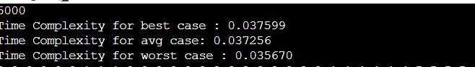

Graph
